Exploring Media Products
Assignment 1, Task 2: Teen Scene Competitor Research – Explore how media products are created to provide meaning and engage audiences (LA B)

Media Product 1 – Amazon
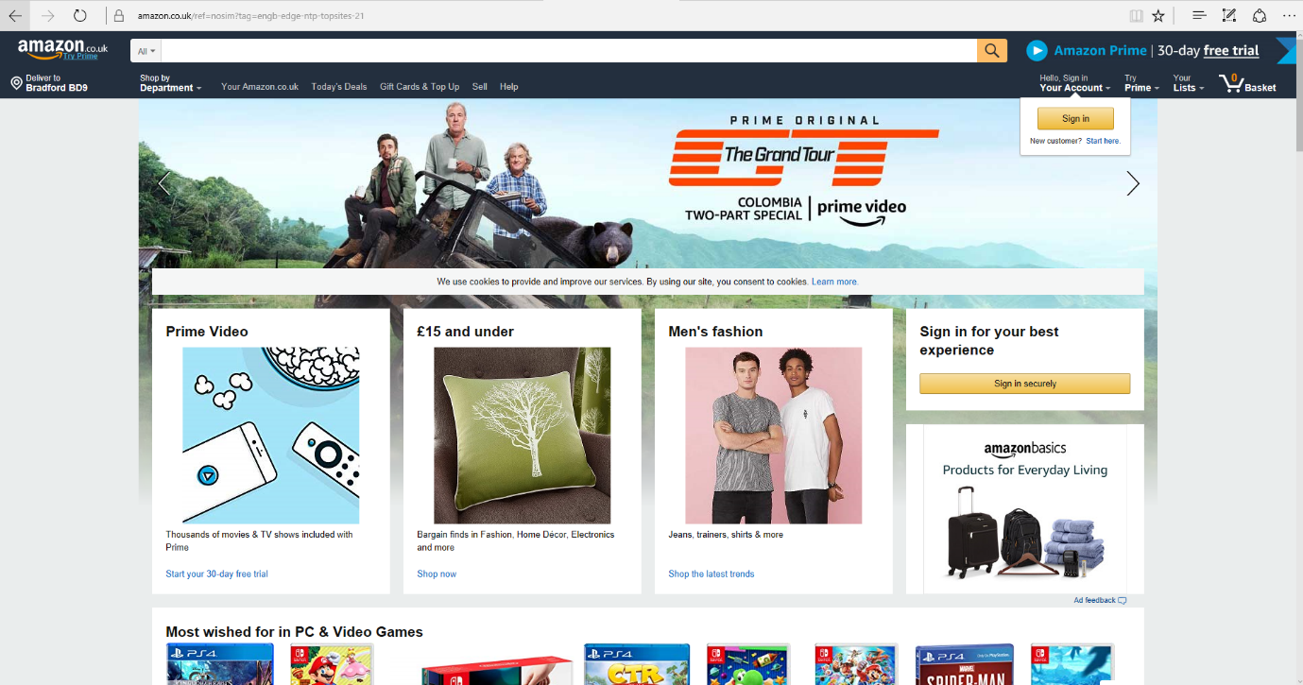

Media Product 2 –

Media Product 3 –

Bibliography
https://www.amazon.co.uk/ref=nosim?tag=engb-edge-ntp-topsites-21, accessed 31/01/2019

