NAME | TUTOR GROUP

WARNING: WHEN YOU ARE ASKED TO TYPE IN THIS TASK, TYPE IT! DO NOT COPY AND PASTE. IT WILL NOT WORK!

Open IDLE (Python GUI). You will get a window that should look like the screen shown below on the left. This is called the ‘Python Shell’.

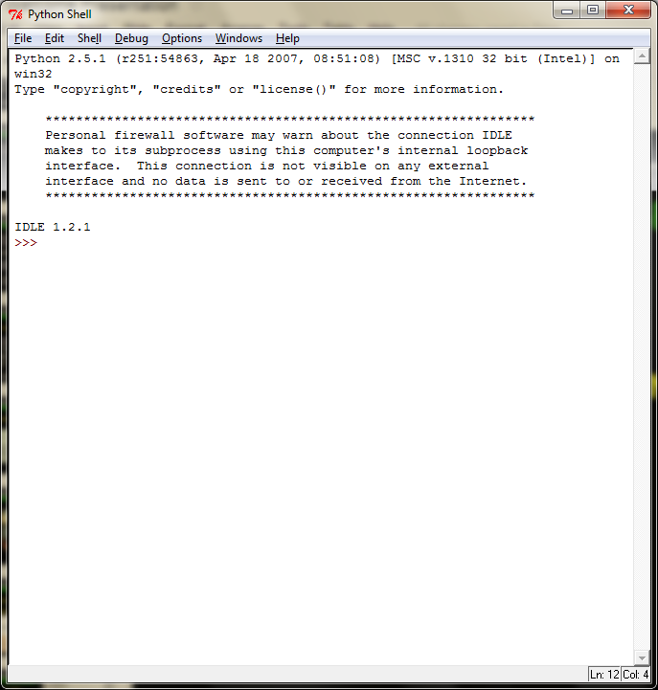

It is tradition that everyone’s first program is always the ‘Hello World’ program. This prints out the words Hello World onto the screen.

Inside the Python Shell type the following code and then press enter:

print(“hello world”)

What happened when you pressed enter?
it said hello world

The computer will print out exactly what is written between the speech marks “ “. Try to write a line of code to print out the things in the table below. Copy the line of code you had to type to make it happen.
Your name
Your favourite food
Your age
Type in the following line of code:

print(10)

What happened when you pressed enter?

Type in the following line(s) of code, pressing enter after each line:

print(10*2)

print (5+1)

print (6-7)

What happened when you pressed enter?

So far you have been writing code one line at a time. Next you are going to learn to program by giving Python a full set of instructions.

Inside your Python Shell click on File > New Window. A new window will appear.

Type in the following block of code:

print (“hello world”)
print (“My name is (INSERT YOUR NAME) and I am learning to program”)
print (“I can print out text”)
print (“3+3=”)
print (3+3)
print (“4*5=”)
print (4*5)

Python is helpful and colours your code to make it more understandable. Anything in green is a string, which means Python treats it as text and will print it exactly as it appears.

Open your Documents folder and create a new folder called Python.

Click on File > Save As and save your code with the filename program1.py inside your Pyhton folder.

Click on Run > Run Module.

Your code should then appear in a Shell window.

If it worked - Congratulations! - you have just written your first Python program. If it didn’t, check the code very carefully and ensure that you have typed it correctly. Save it again as program1.py.

Now you can program, you need to write a program to solve the following problems. Write code for each expression, then complete the table showing your code, the result and try to explain what each one does. The first one has been done for you

Expression | Your Code | Result | What does it do?
3+4 | print(3+4) | 7 | Adds 3 and 7 together
57-4 |  | 53 | Take 4 away from 57
4*6 |  | 24 | multiples
7/3
7%3
2**3
3==3
3==6
4<6
4>6
4!=6
range(100)

As an extension task, you need to carry out some research to see if you can find out what the key terms variable and input mean.

