Name: ______________________________________________ Class: _________

Rearrange the sequence to correctly make toast with jam....
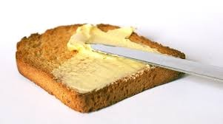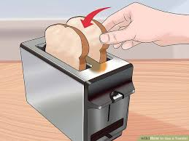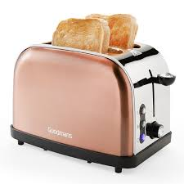

Rearrange the sequence to correctly log in to a school computer
- Type your password in to the correct box
- Switch on the monitor
- Type your username into the correct box
- Sit down
- Switch on the computer
- Press enter
- Wait for the computer to boot up
- Check that the socket switches are set to on
What is missing from the sequence?
- 8723, 3872, 2387, ?
- M, T, ?, T, F, S, S

How do we find out what y is? Rearrange the sequence of steps to find y.
3(y + 30) = 300
- y = 70
- 3y = 300 – 90
- 3y + 90 = 300
- y= 210/3
- 3y + 3*30 = 300
- 3y = 210

