🖨️ How to Format Your Printable 7-Day Planner Guide in Microsoft Word
Here’s how to turn your guide into a professional-looking, printable document:

🧭 Step 1: Set Up the Document
- Open Word and create a new blank document.
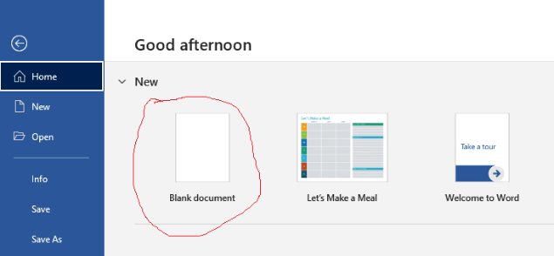
- Go to Layout > Orientation > Landscape.
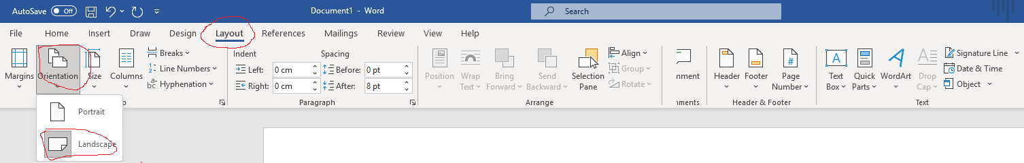
- Set margins:
  - Go to Layout > Page Setup > Margins and set all sides to 2 cm.
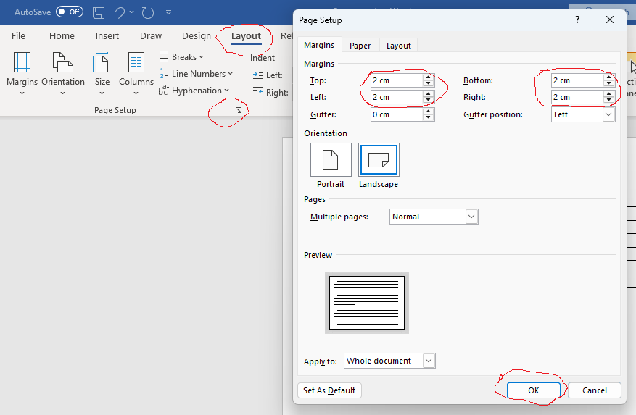

🧱 Step 2: Add Section Headings
Use Heading 1 style for major steps:
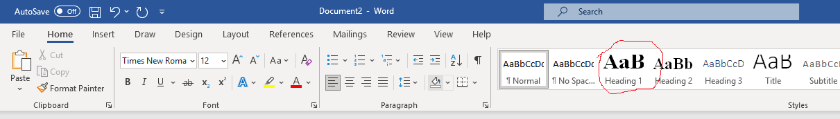
Use Heading 2 or bold text for sub-steps:

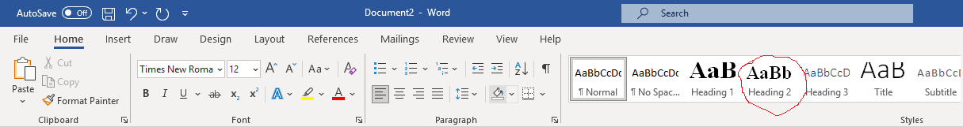

📄 Step 5: Add a Sample Planner Table
- Go to Insert > Table and create a 7-column table.
- Label the side row with days of the week.
- Add time slots or task sections across the top of the table columns.
- Use Shading and Borders under Table Design to style it.
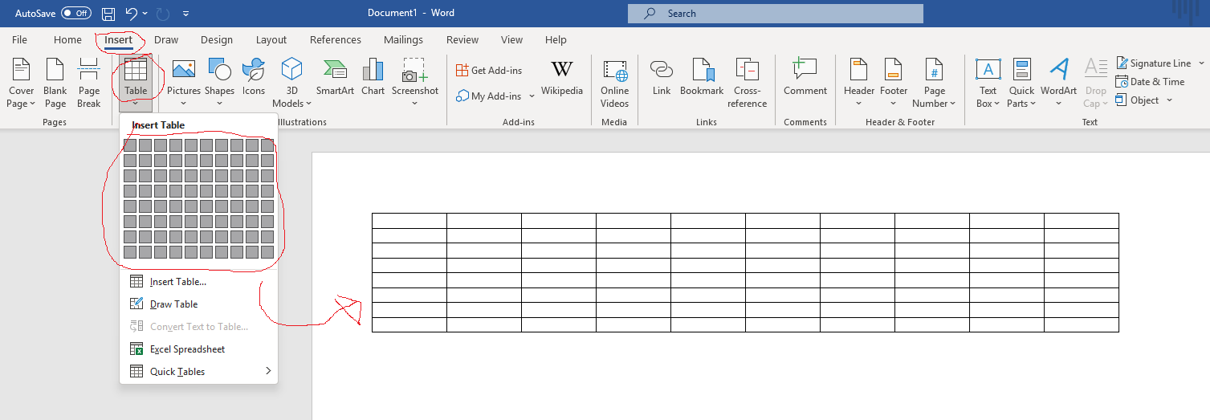
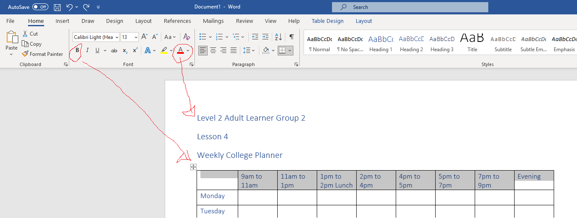

💾 Step 6: Save
- Save your document:
  - File > Save As > Word Document (.docx) or PDF (.pdf).
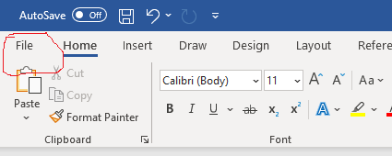
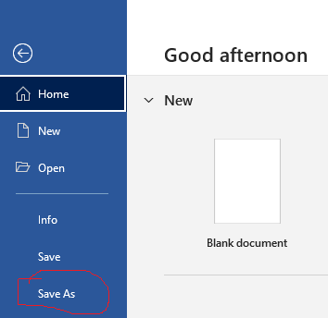
  - You can also save it to your OneDrive

✅ Optional Enhancements
- Add a cover page with title and date.
- Include a notes section at the bottom.
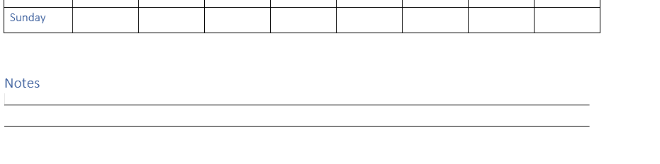

CHALLENGE
- Try and create a planner like the one below using a Microsoft Word Template
