Contents
Unit 10: Database Development – Assignment 1 0
TASK 1 2
SCENARIO 2
A CAR SALES SYSTEM 2
THE INTENDED USE AND FEATURES OF THE DATABASE 2
TYPE OF DATABASE 3
TOOLS AND TECHNIQUES 4
TABLE 1 - CARS 4
TABLE 2 – CUSTOMERS 4
TABLE 1 & 2 REVIEW 5
TABLE 1 REVIEW 5
TABLE 2 - REVIEW 5
FORMS 6
MENU 6
CAR DETAILS 6
CUSTOMERS 7
SELL A CAR 7
A LIBRARY SYSTEM 8
THE INTENDED USE AND FEATURES OF THE DATABASE 8
TYPE OF DATABASE 8
TOOLS AND TECHNIQUES 9
table 1 – books 9
TABLE 2 – BORROWERS 9
TABLE 1 & 2 REVIEW 10
TABLE 1 REVIEW 10

TASK 1

SCENARIO
You work for a local health authority and have been asked to develop simple information management systems for doctors’ surgeries to use in the area. Before you design a database solution, you want to prepare a demonstration to show how databases are currently used in two different ways by organizations.

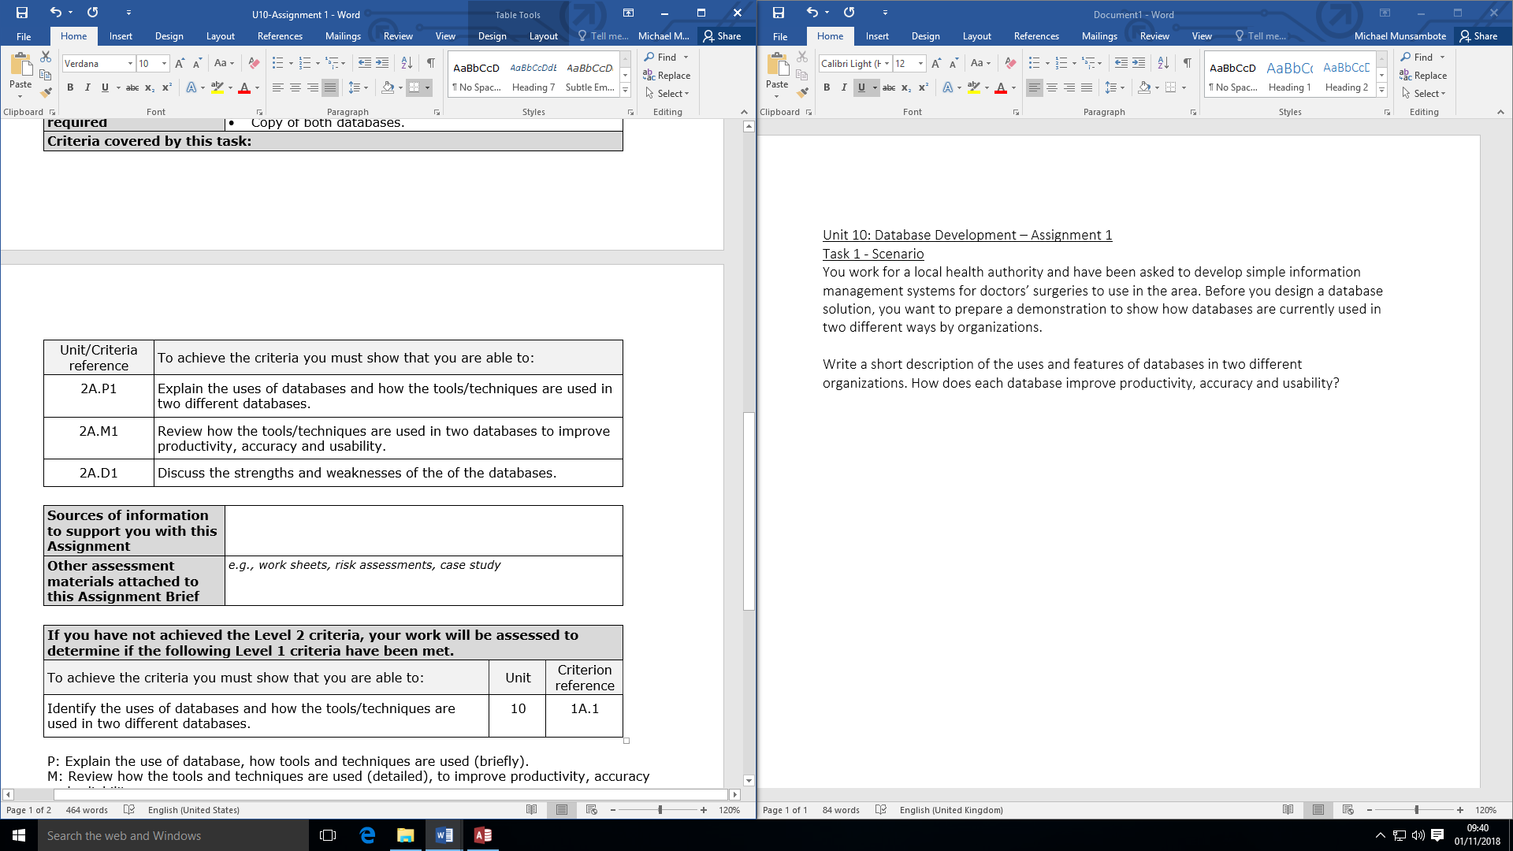

A CAR SALES SYSTEM

THE INTENDED USE AND FEATURES OF THE DATABASE
A use of database is to store the information that the business will need on a day to day basis and for this car dealership company they would have to store information about the cars they are selling such as mileage, registration, manufacturer, model, gearbox, colour, engine type and other specifics about the vehicles. They have also must include information about their customers such as their phone numbers, forename, surname, address and DOB. The car dealership company have also included information about how many cars have been bought and by whom. They have also included a unique ID for each vehicle and customer, no two ID are the same. The database also includes the cars registration plate, what make of car they are, the number of doors, gearbox, mileage, colour, registration, engine type, price and whether it’s been sold or not all of these are important information to have on a car dealership database because it’s information that customers would want to find out, this table has a different unique key and this is the registration plate of the cars as no two cars will have the same registration plate. For example, looking at the database I can see that someone has bought a Land Rover Outlander for £22,500, and someone hasn’t bought a Rolls Royce Wraith which is going for £158,99. In the customer’s database they have stored the customer’s names (forename and surname), their address and phone number this information is important because if a customer needs to be contacted their details would be on the system. On the database they have included a customer sales section and in this is where the customers who have bought vehicles names and information will be stored. For example, looking at the database you can see that the customer Garp Ace from Coventry has bought 4 cars from the dealership a Cadillac Thunderbird coupé, Land Rover Rang Rover, Austin Cambridge Estate and a Land Rover Outlander for the prices £12.50, £8,999.00, £33.00 and £22,500.00. This information is important because the manager would want to how many cars are being bought from their dealership. Also they have included an unsold cars section, and here is where the unsold cars are going to be stored, the unique key for this table is the same as the unique key from the cars table as the cars table as only cars that haven’t been sold are stored there.

TYPE OF DATABASE
This type of database is called local database. In a local database all the customers and confidential business information are kept within the business only and not shared online. Local database is used by a lot of businesses because it stores information about the employees and customers which can’t be shared online such as their phone numbers. The relationship between customers and customer sales is one to many as the customer’s unique ID is reused so show which vehicles they have bought and for how much. The reason why one to many relation is because some information such as the unique ID can be reused on other tables, this means you don’t have to write all of the user’s information which lowers the risk of inputting the wrong information.

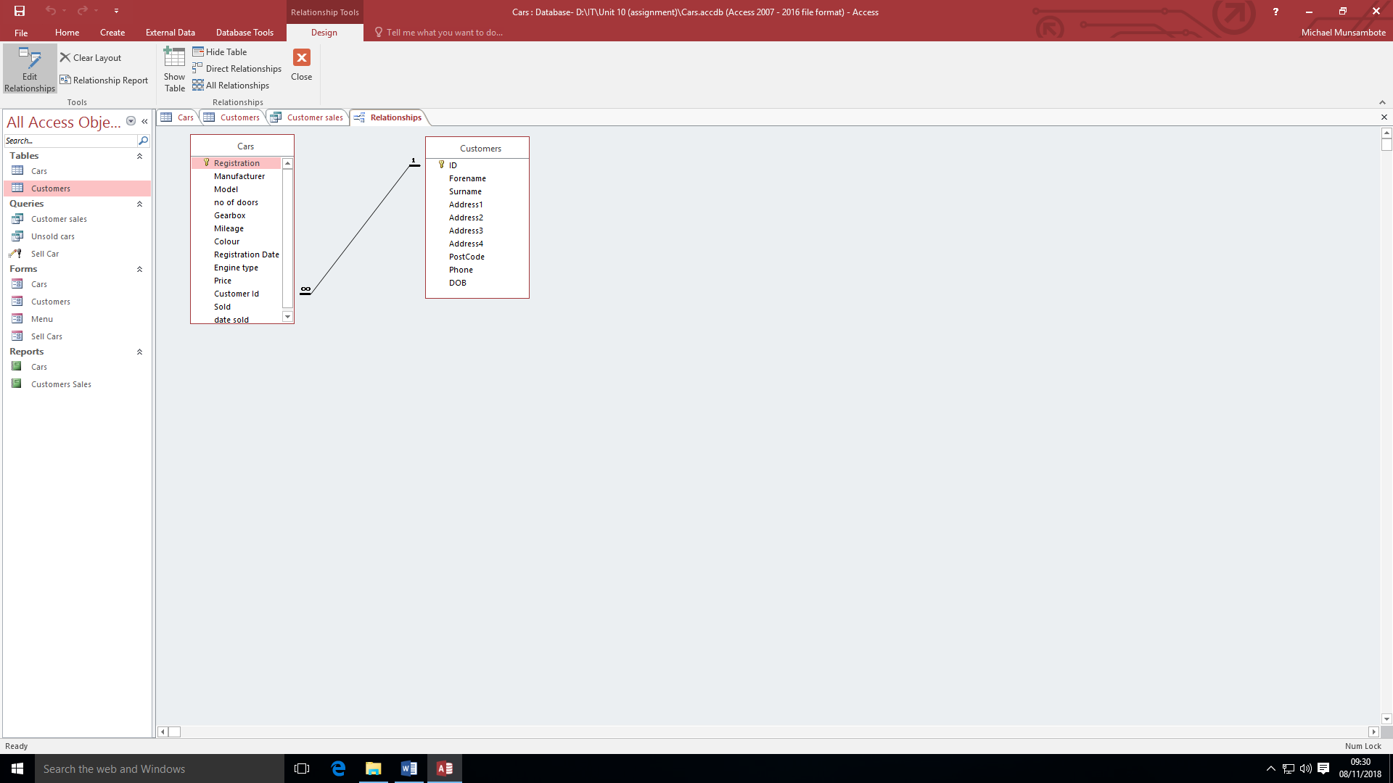

TOOLS AND TECHNIQUES

TABLE 1 - CARS
Field Name | Data Type | Field Size | Format | Indexed
Registration | Short Text | 25 | @ | Yes (No duplicates)
Manufacturer | Short Text | 25 | N/A | Yes (Duplicate OK)
Model | Short Text | 50 | @ | No
No of doors | Number | Double | General Number | No
Gearbox | Short Text | 25 | @ | No
Mileage | Number | Double | General Number | No
Colour | Short Text | 25 | @ | No
Registration date | Date/Time |  | dd/mm/yyyy | No
Engine type | Short Text | 25 | @ | No
Price | Number | Double | Standard | No
Customer ID | Number ID | Long Integer | N/A | Yes (Duplicates OK)
Sold | Yes/No | N/A | Yes/No | No
Date sold | Date/Time | N/A | N/A | No

TABLE 2 – CUSTOMERS
Field Name | Data Type | Field Size | Format | Indexed
ID | AutoNumber | Long Integer | N/A | Yes (No Duplicates)
Forename | Short Text | 30 | @ | No
Surname | Short Text | 30 | @ | No
Address 1 | Short Text | 30 | @ | No
Address 2 | Short Text | 30 | @ | No
Address 3 | Short Text | 30 | @ | No
Address 4 | Short Text | 30 | @ | No
Postcode | Short Text | 30 | > | Yes (Duplicates OK)
Phone | Short Text | 30 | @ | No
DOB | Date/Time | N/A | dd/mm/yyyy | No

TABLE 1 & 2 REVIEW

TABLE 1 - REVIEW
The first field in this table is called registration and the data type for this field is short text because registration plate numbers aren’t long. The field size is set to 25 because it won’t take up a lot of storage and registration plate numbers. The format is set to @ which leaves the characters how the users entered them. The indexed in this field is set to “Yes (No Duplicates) and this means there can’t be more than one of the same registration plate number. The next field is called manufacturer and the data type for the field is short text as most car manufacturer’s don’t have long names. This field also gives the user a certain amount of manufacturers to pick from. This field does not have a format because the only information being entered is the manufacturers name. The field size is set to 25 because the names of the manufacturers aren’t longer than 25 and this also saves on storage space. This field doesn’t have a format. In the indexed part of the table its set to ‘Yes (Duplicate OK)’ this means that there can be more than one of the same manufacturer in the table. The field name model has the data type called short text because car model names aren’t very long which is why the field size is set to 50 which is enough for the car model as the names aren’t very long. The format is “@”. The next fields “no of doors” and “Mileage” the data type for these fields is “number” as only numbers will be entered. The format for this field is general number as there will only be numbers entered into the field.

TABLE 2 - REVIEW
The first field in this table is “ID” this field is an “AutoNumber” as it is the primary key no numbers can be the same. The next fields “Forename”, “Surname”, “Address 1”, “Address 2”, “Address 3”, “Address 4” and “Phone” are all short text meaning they aren’t long. They all also have a field size of “30” and the format for these is “@” which leaves the characters how the users entered them. The field name “Postcode” and the data type is “Short Text” as post codes are not long which is why the field size is “30”. The format is “>” which turns all the letters and numbers entered into capitals.

QUERIES

CUSTOMER SALES
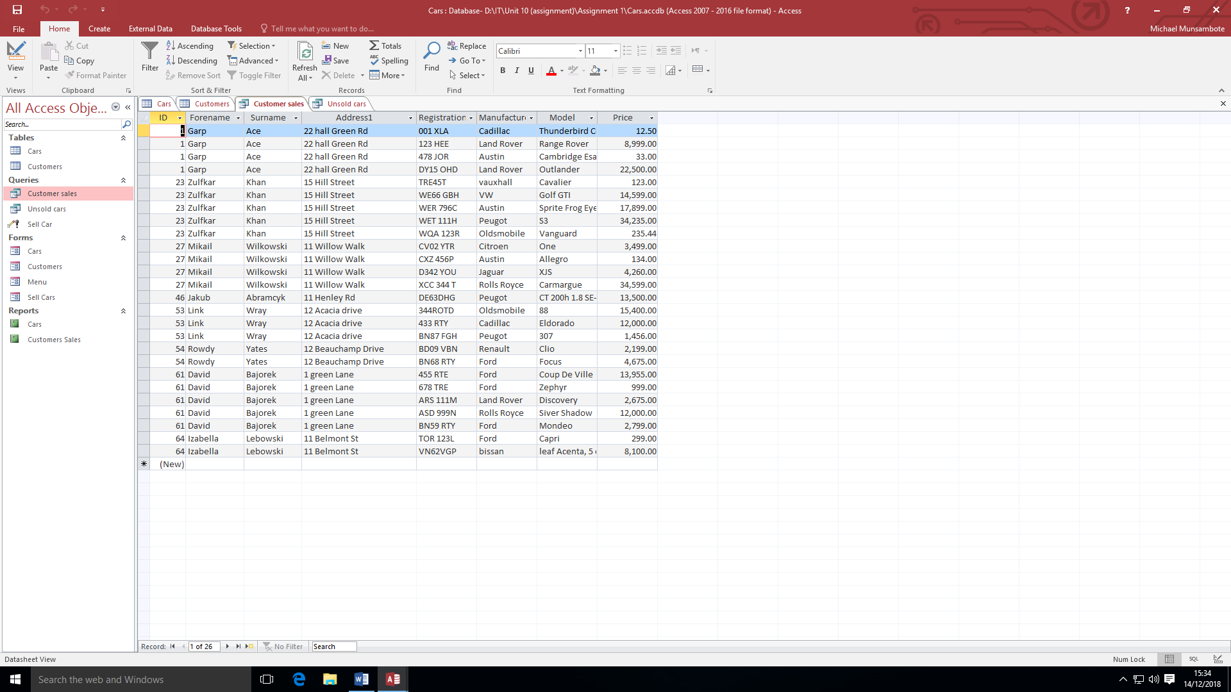
In the query customer sales, you can see which cars have been bought by which customer. This table shows you the customers unique ID, the forename, surname, address, the cars registration, manufacturer, model and price and if a customer hasn’t bought a car their name won’t appear within the table.

UNSOLD CARS
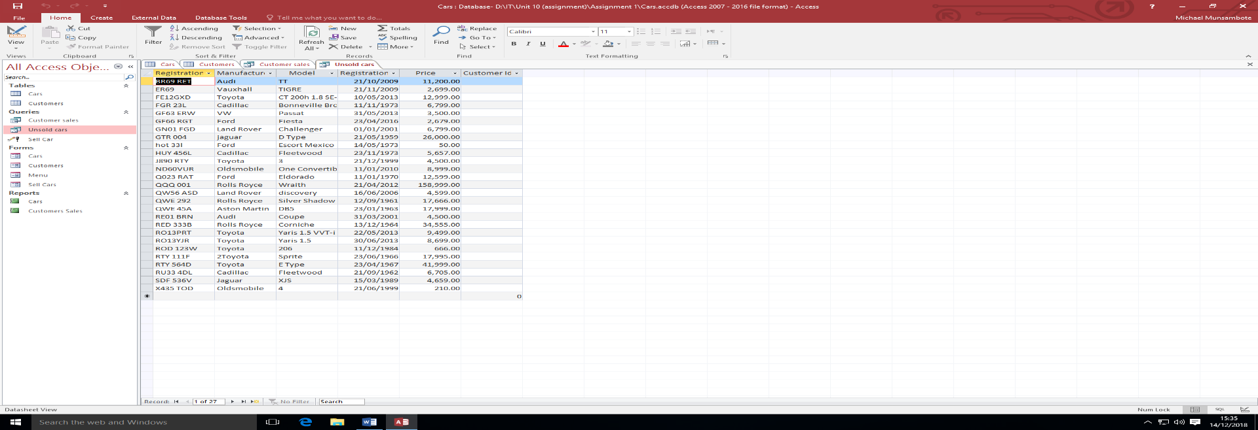
In this query you can see which car has been sold. The table shows you the cars registration plate number, manufacturer, model, registration date and price. To include if a car hasn’t been bought then the car will not appear within the table.

SELL CAR
The next query is called sell car and this table would show what cars have been bought, and it updates the customer sales table

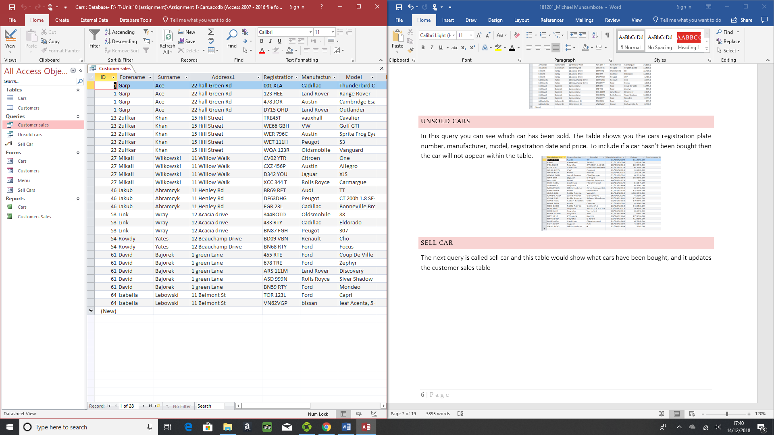

FORMS

MENU
Within the database there are forms and the first form is called “Menu” and from the menu form you can travel to the other forms which are labelled car details, customer details and sell car. In the car details form there is information about all the vehicles that the company is selling. Similarly, in the customer details form there is going to be all the customer’s information. The last field sell car is where the user will be able to sell cars to customers.
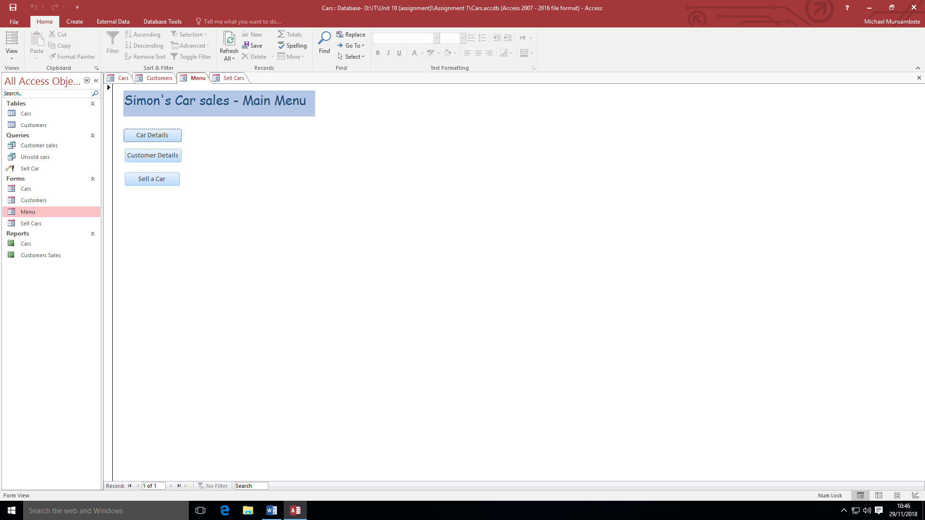

CAR DETAILS
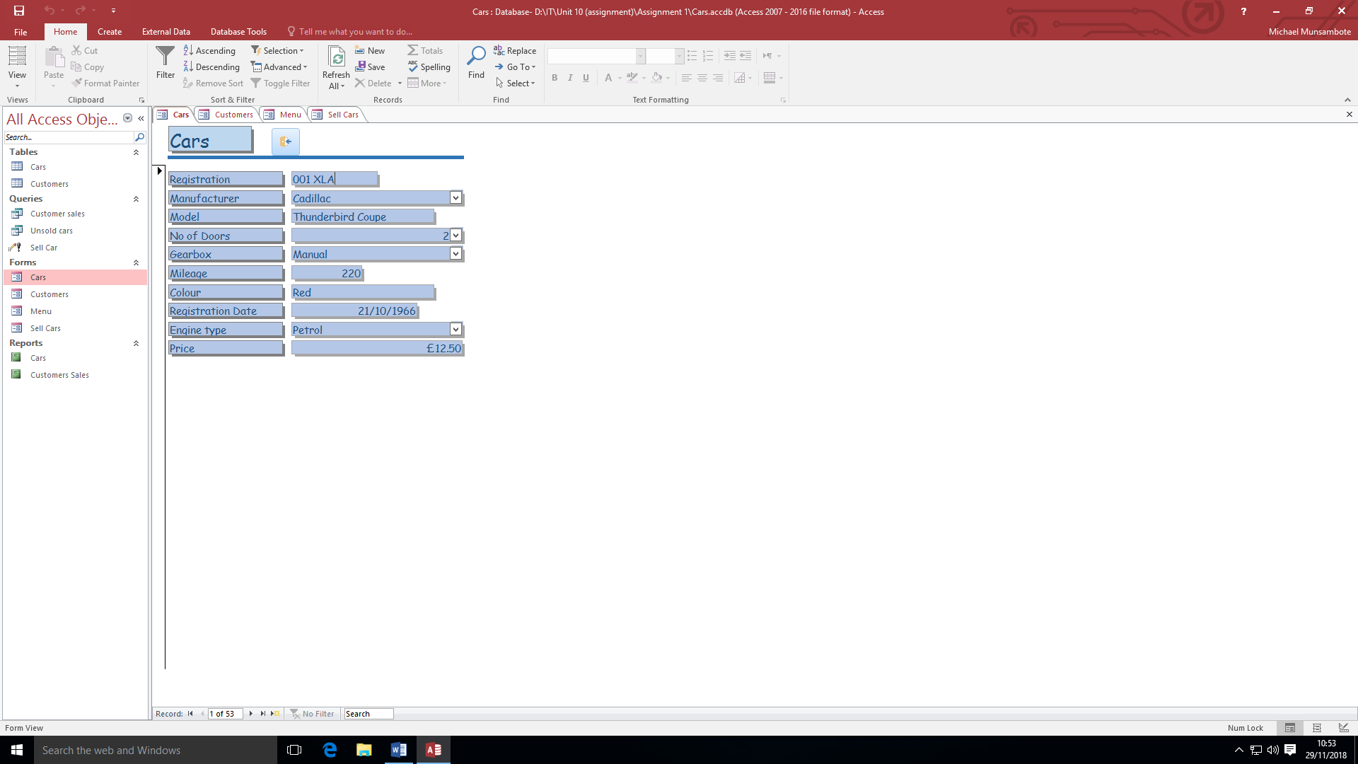
In the cars form you can scroll through the and see what cars are available in the company. You can also see all of the cars information such as its registration, manufacturer, model, no of doors, gearbox, mileage, colour, registration date, engine type and price. In addition to this you can also add new vehicles into this however it does not add the vehicle to the vehicles table meaning this part of the form is complete.

CUSTOMERS
This form is similar to the Cars form however this form displays information about the customers. The form displays their Unique ID, forename, surname, Address 1, Address 2, Address 3, Address 4, PostCode, Phone and DOB. Also you can add new customers to this form. This is evident as I have added myself to the customers list. At first I was not on the customers list and after I entered my details into the form I appeared on the list
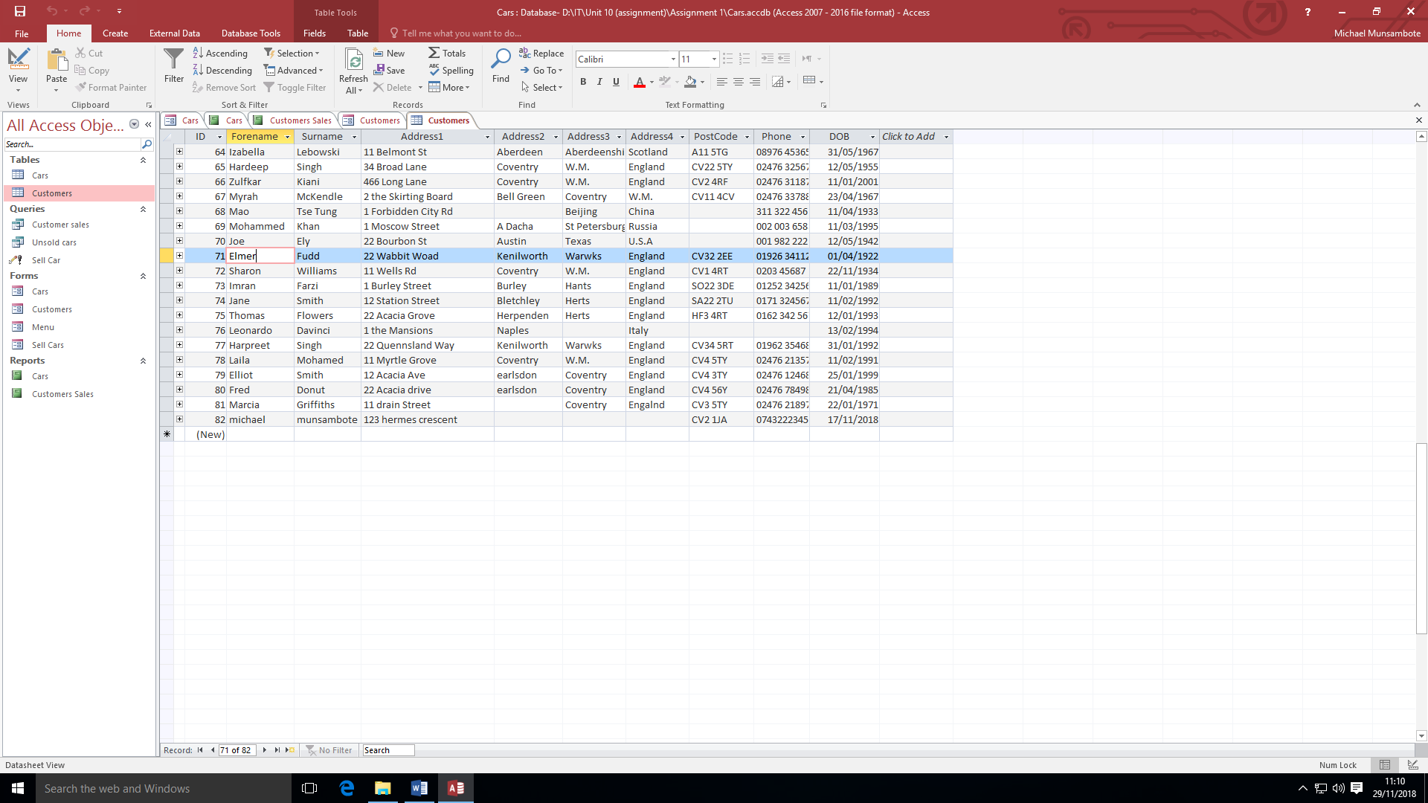
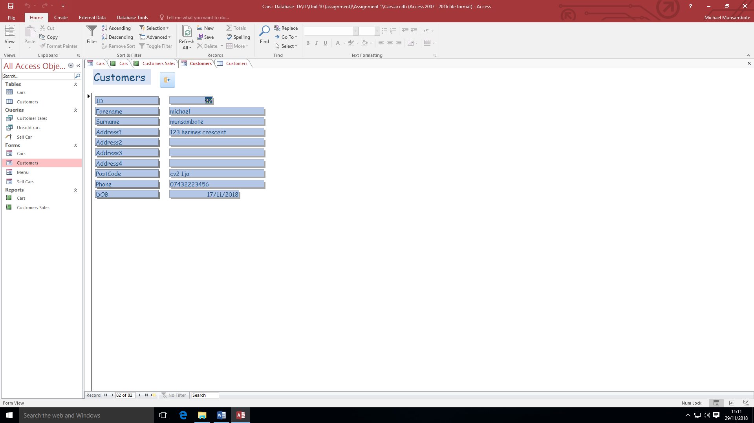

SELL A CAR
The Sell a Car form is where you can sell cars to a customer. This is done by selecting a vehicle and then selecting the customer that wants to buy the vehicle. In the choose car section, it shows that cars registration plate number, manufacturer, model, registration date and price. In the choose customer section is shows the customers unique ID number, their first name and last name.
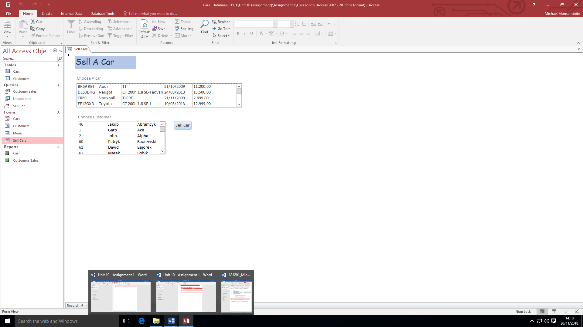

REPORTS

CARS
The first report is called cars and this report is a list of all the cars the car dealership has available to sell. They are sorted alphabetically buy the type of car and the price of all the type of cars they have.
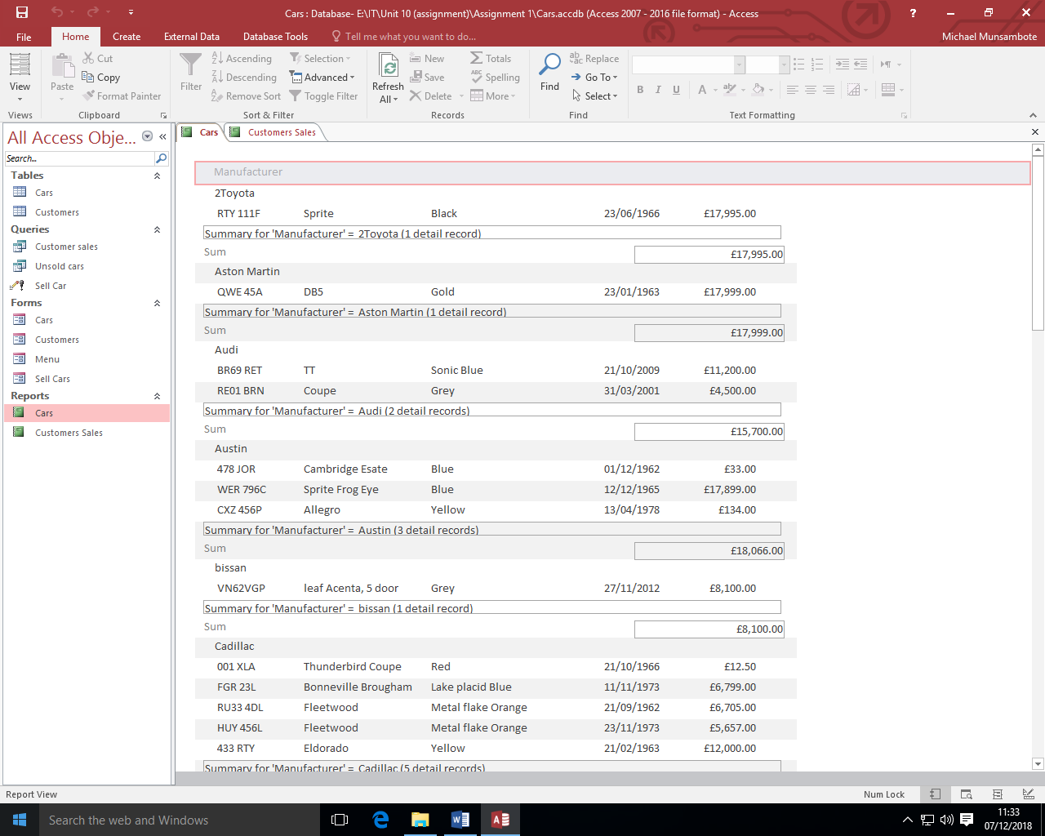

CUSTOMER SALES
The following report is called customer sales and in this report is also a list but of customers who have bought cars from this they have also included a sum of all each customer’s expenses at the dealership.
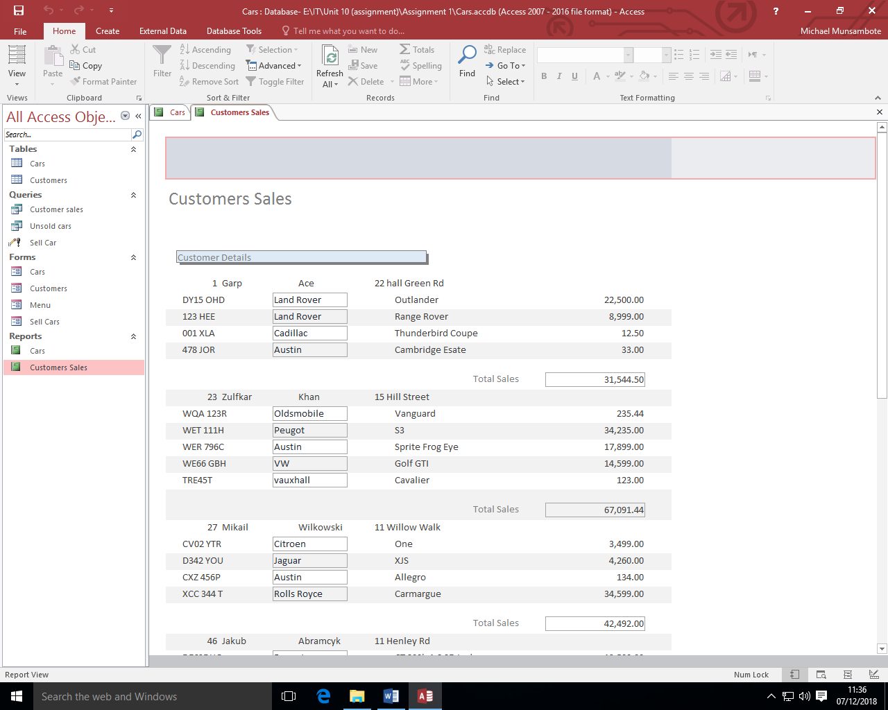

ADVANTAGE & DISADVANTAGE OF THE CARS DATABASE

ADVANTAGE
An advantage of the Cars database id that there are clear heading indicating what title leads to what table, queries, form, or report. Another advantage of the Cars database is that within the cars table you can see all of the cars information that you would want to find out, such as their manufacturer, model, no of doors, gearbox, mileage, colour, registration date, and engine type. You can also see whether they have been bought or not. Another advantage is in the customers table and in his table all of the customer’s details are labelled, there aren’t missing information. Another advantage of this table is the customers are sorted by their unique ID number. Another advantage is that the table has query called customer sales and in this table you can see all customers that have bought a car and this table also shows which car they have bought. Another advantage is you can see which cars haven’t been sold in the unsold cars query. Another advantage is that you can update the table in the forms section as if a new customer buys a car it will update the table.

DISADVANTAGE
A disadvantage of this database is that in the cars form you cannot add new cars to the database.

A LIBRARY SYSTEM

THE INTENDED USE AND FEATURES OF THE DATABASE
A use of database is to store the information that the library will need on a day to day basis and for this library they would have to store information about the book they have available. The information that they store is the name of the book, author, publisher, who has borrowed it and when it has to be returned, for example I can see that someone has borrowed a book from the library and the book is called “Watchmen” this book is by Alan Moore and it was published by “Penguin”, the borrower’s unique ID is “6” and the book has to be returned on the 06/03/2018. Another use of the library system is to store the library's borrower’s information such as their forename, surname, addresses, post code and phone number. This table also gives the borrowers unique ID numbers and every borrower has their own unique ID number. For example, the borrower Fred Smith live on 1 Sloane St, Chelsea, London SW3, England, CH2 1WQ and his phone number is 0181112321. From looking at the table I can see that Imran Sheikh has borrowed a book called “The Hearts of the Matter” and this book has to be returned by the 06/03/2018. This information would be important for the library and would have to updated daily as libraries have a lot of customers daily and if a book that someone is requesting is not available it would be the libraries responsibility to know who has borrowed the book and to know when it is going to be returned so the person asking for it can come get it by then.

TYPE OF DATABASE
The type of database is called local database. In a local database all the customers and confidential business information are kept within the business only and not shared online. Local database is used by a lot of businesses because it stores information about the employees and customers which can’t be shared online such as their phone numbers. This is why this database is a local database because confidential information about the borrowers are not shared online or to other libraries. The relationship between the two fields is called one to many as the customers unique ID are reused in the book section to indicate which customer has borrowed which book. Making the tables one to many means there is no need to rewrite information which can lowers the risk of the user inputting the wrong information.
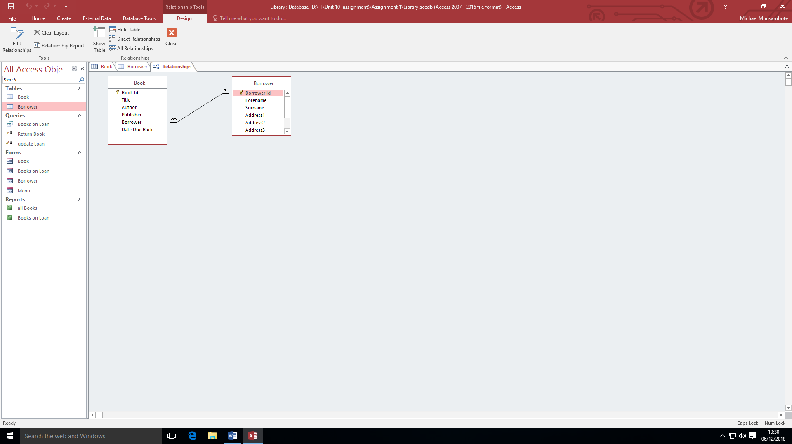

TOOLS AND TECHNIQUES

TABLE 1 – BOOKS
Field Name | Data Type | Field Size | Format | Indexed
Book ID | AutoNumber | Long Integer | N/A | Yes (No duplicates)
Title | Short Text | 30 | @ | No
Author | Short Text | 30 | @ | Yes (Duplicates OK)
Publisher | Short Text | 30 | @ | No
Borrower | Number | Long Integer | N/A | No
Date Due Back | Date/Time | N/A | Short Date | No

TABLE 2 – BORROWERS
Field Name | Data Type | Field Size | Format | Indexed
Borrower ID | AutoNumber | Long Integer | N/A | Yes (No Duplicates)
Forename | Short Text | 30 | @ | No
Surname | Short Text | 30 | @ | No
Adress1 | Short Text | 30 | @ | No
Address2 | Short Text | 30 | @ | No
Address3 | Short Text | 30 | @ | No
Address4 | Short Text | 30 | @ | No
Postcode | Short Text | 30 | @ | Yes (Duplicates OK)
Phone | Short Text | 30 | @ | No

TABLE 1 & 2 REVIEW

TABLE 1 – REVIEW
The first field in this table is called “Book ID” and this where the books get their unique ID numbers which is why the data type is AutoNumber this is because it will give the book a number. and the field size is long integer because if the library buys more books they would have to add it to the list of books. There is not a format as only numbers types. However, the field is indexed but not duplicated meaning the unique ID of the book are not going to be reused. The fields “Title”, “Author” and “Publisher” both have the data type short text because names of books are not long, which is why the field size is 30, this is because it will save up on storage space and book names aren’t very long. The format is set to “@” this means what the user types into the field will stay as it is. The field “Title” and “Publisher” are not indexed where as “Author” is indexed and available for duplicates because the library might have more than one book from an author. The field “Borrower” is where the people who have borrowed books unique codes are going to be stored and this is why the data type is set to number. The field size for this field is long integer. There is no format as only number are going to be typed into this field and it is not indexed. the final field is called “Date Due Back” and in this field is the date when the books have to be returned. The data type is set to date/time because only dates are going to be types into this field. There is no field size as only dates will be entered here. The format is “short date” because it saves storage. This field is not indexed.

TABLE 2 - REVIEW
The first field in this table is called “Borrower ID” and this is where the customers ID and the data type for this field is AutoNumber this is because it will give the book a number. The field size is Long integer because if more and more people borrow books the number will keep going up. There is no format for this field. It is indexed but not duplicated. The fields “Forename”, “Surname”, “Address1”, “Address2”, “Address3”, “Address4”, “Phone” and “Postcode” all have the same information. They all have the data type Short Text. They all also have the field size of 30. All their formats are @ this means whatever the user inputs will remain as it is. They all aren’t indexed. However, “Postcode” is indexed and is available for duplicates.

FORMS

MENU
In the database there are forms and the first form is called “Menu”, and from the menu form you can travel to other forms. The other forms you can travel to are lend a book and in lend a book you would register who has rented which book. The following form is called return book and in this form is where you would register who has returned which book and when. The last form is called list borrowers and in this form is where you would see all the people who borrow books names.
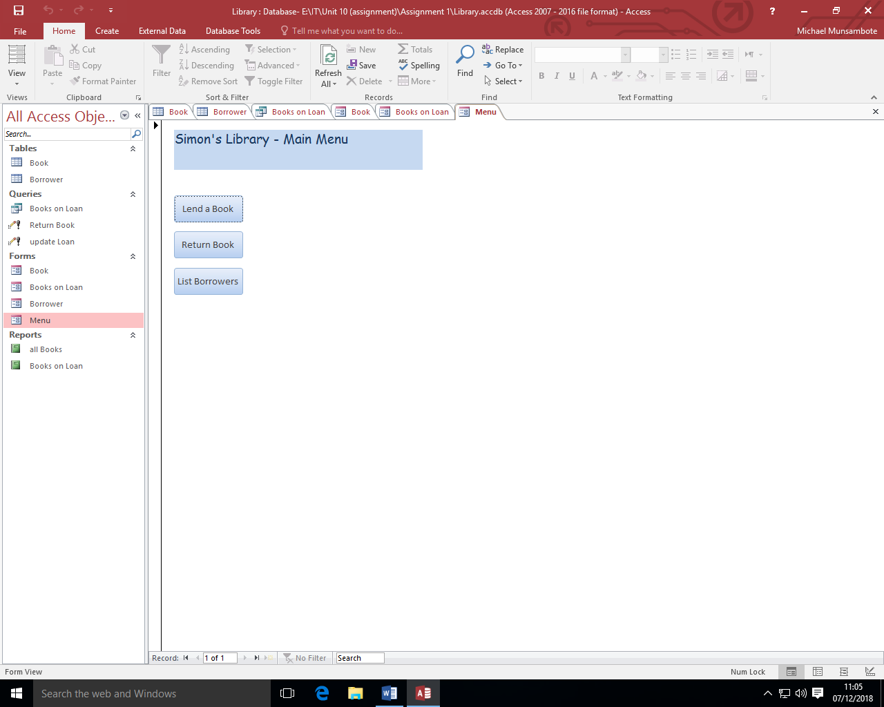

LEND A BOOK
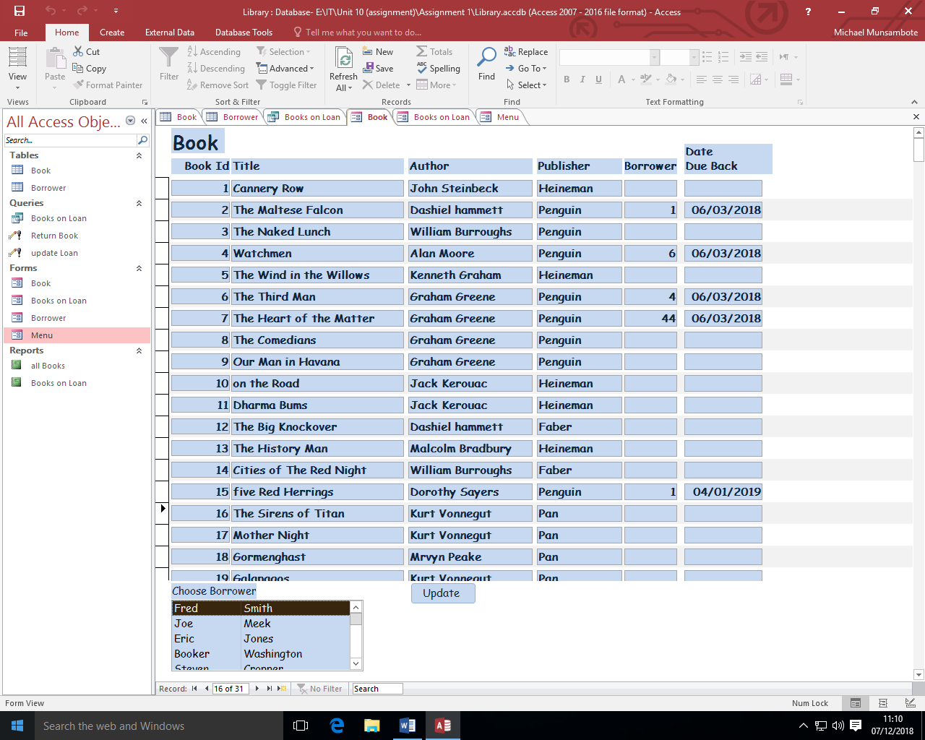
When you click onto lend a book you would see 2 tables and in the first table is a list of all that books the library has available and it would also show their author, publisher, whether they have been borrowed or not and the date is has to be returned. The second table shows all the borrowers first name and last name. You can then click onto a picture and choose a name. you can choose a book and name and pair them and it would update the table.

RETURN A BOOK
In this form there is a list of the book of the books that have been borrowed. The heading on this table are the books unique ID, followed by the name of the book, and then the author of the book, the publisher, the borrower’s unique ID and then the date due back. This form is also ordered by the date they have to be returned, they date closet is at the top.
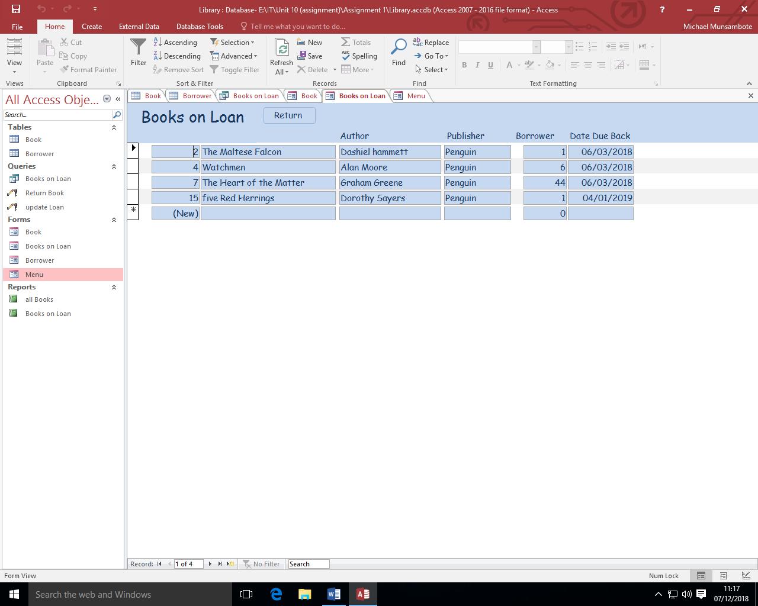
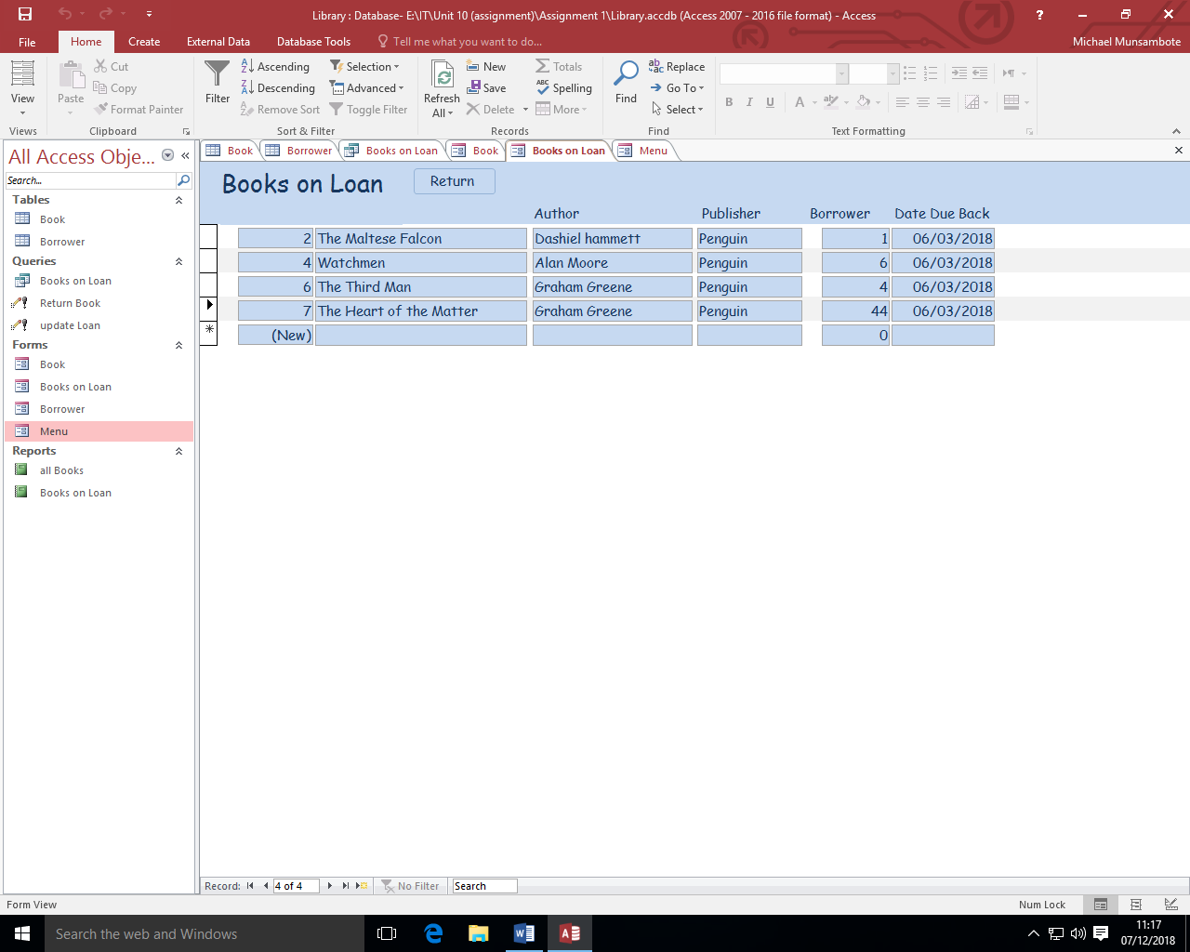

LIST BORROWERS
In this form is where you can see all the names of the user who have borrowed a book. This form is in a table form. The titles on this table are Borrower ID, Forename, Surname, Address1, Address2, Address3, Address4, Postcode and phone. This information would be important because the library would be able to send them reminders to return a book. You can also switch through this form and see other people who have borrowed books.
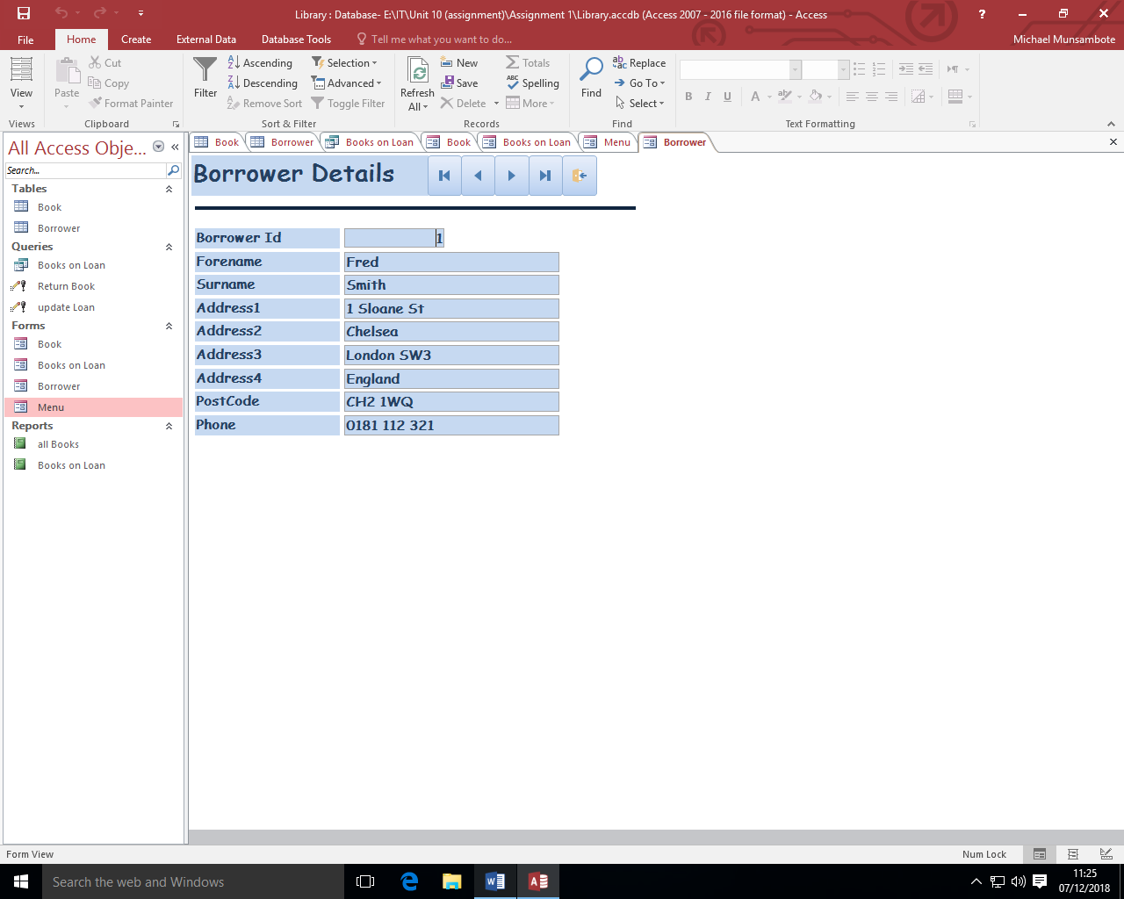

REPORTS

ALL BOOKS
This report is a list of all the books the library has. They are ordered by author, there’s the authors name and then which of their books they have available.
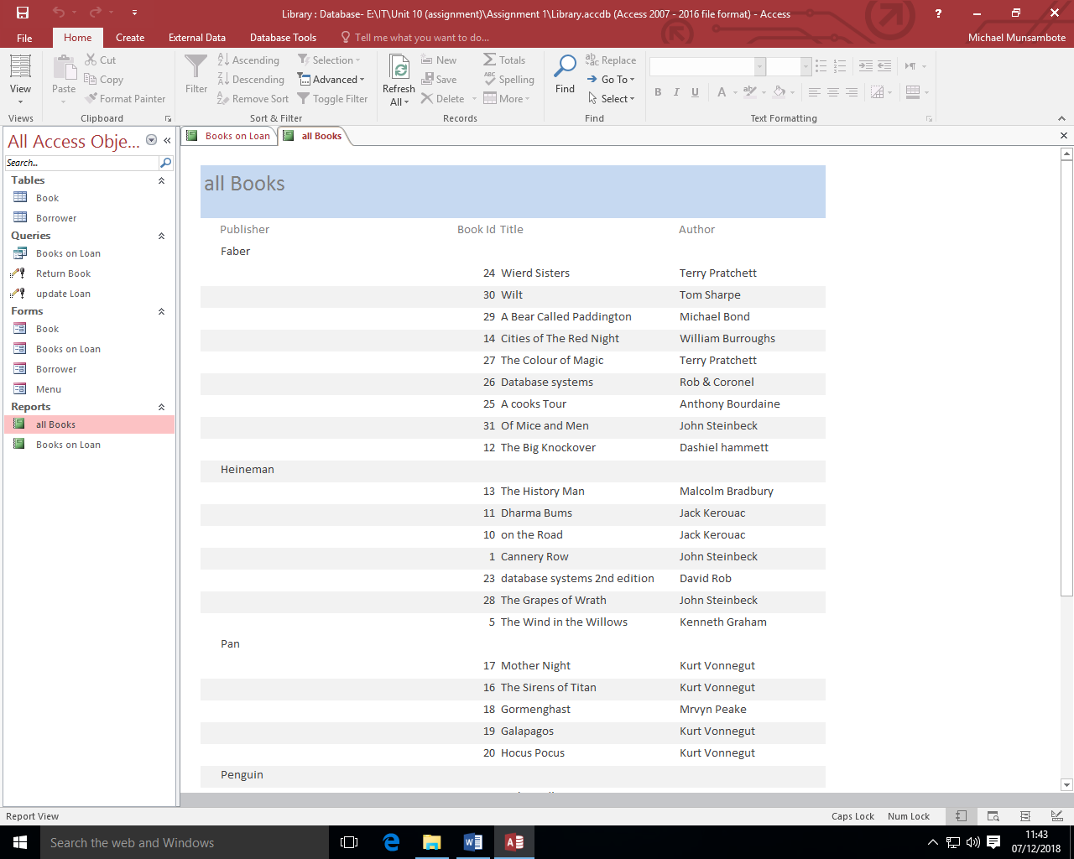

BOOKS ON LOAN
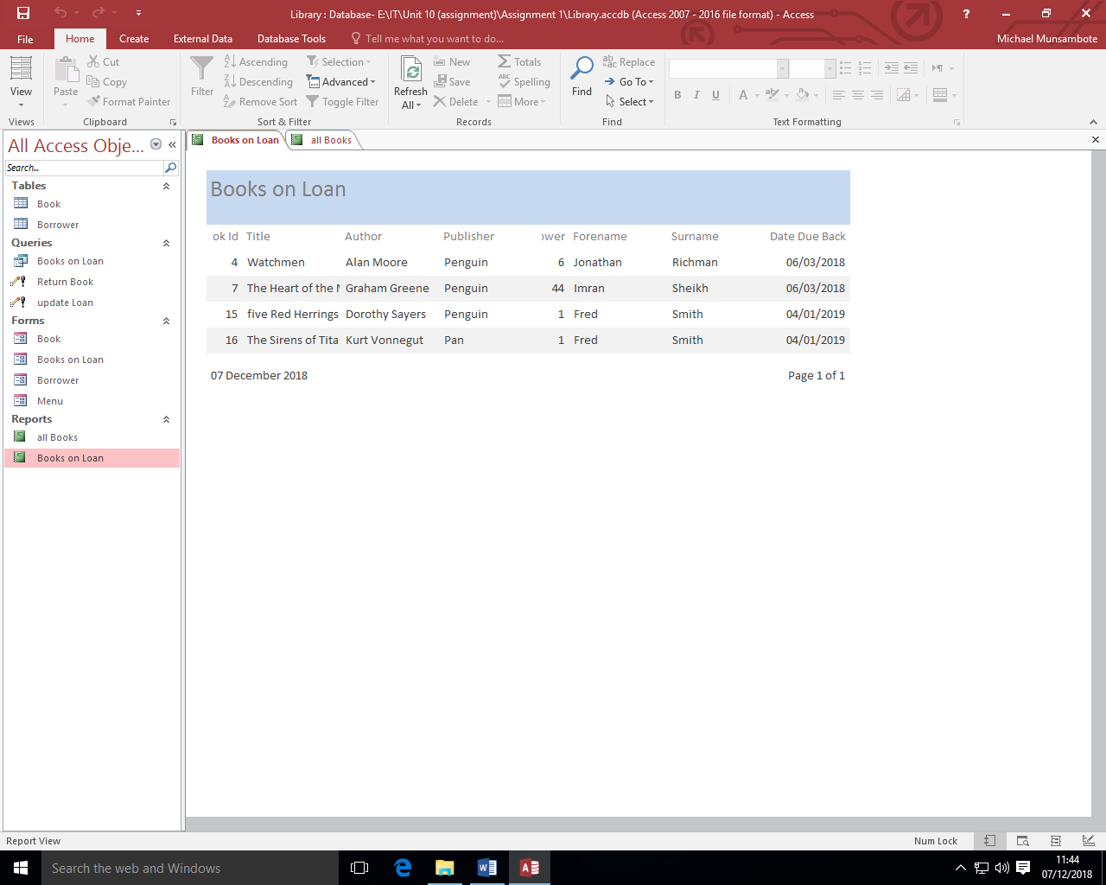
In this report is a list of all the books the library has on loan. This list contains of the Books unique ID, the title of the book, the author of the book, the publisher, the borrower’s unique ID, their forename, surname and the date it has to be returned by.

QUERIES

BOOKS ON LOAN
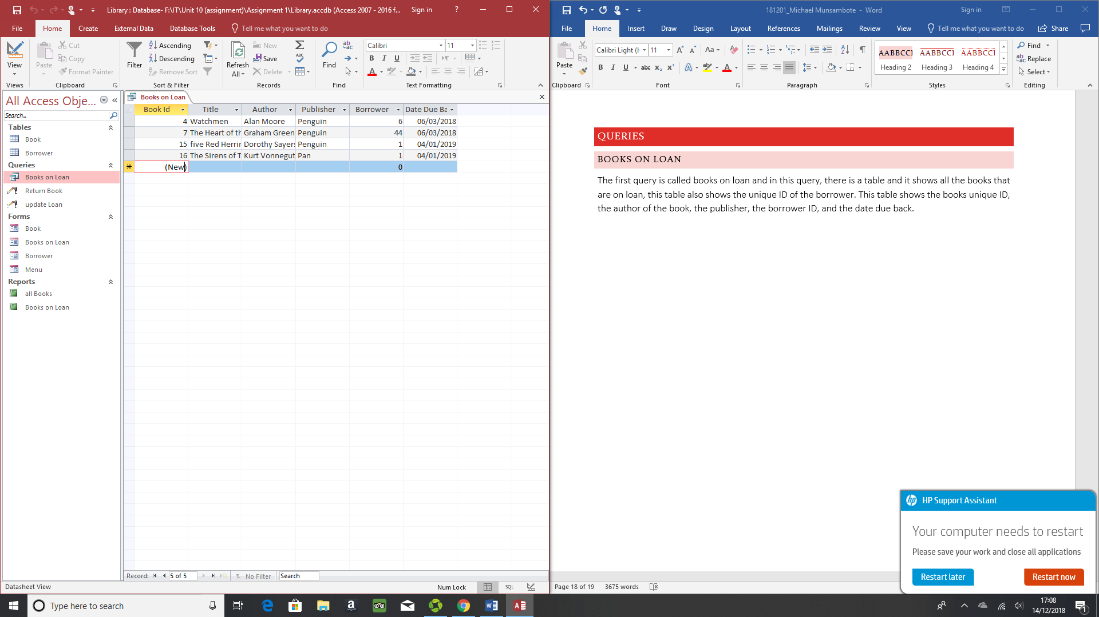
The first query is called books on loan and in this query, there is a table and it shows all the books that are on loan, this table also shows the unique ID of the borrower. This table shows the books unique ID, the author of the book, the publisher, the borrower ID, and the date due back.

RETURN BOOK
This query is called return book and in this query is where you would update the table is a borrower has returned a book. This is done by entering the books ID and after doing so it would update the table.
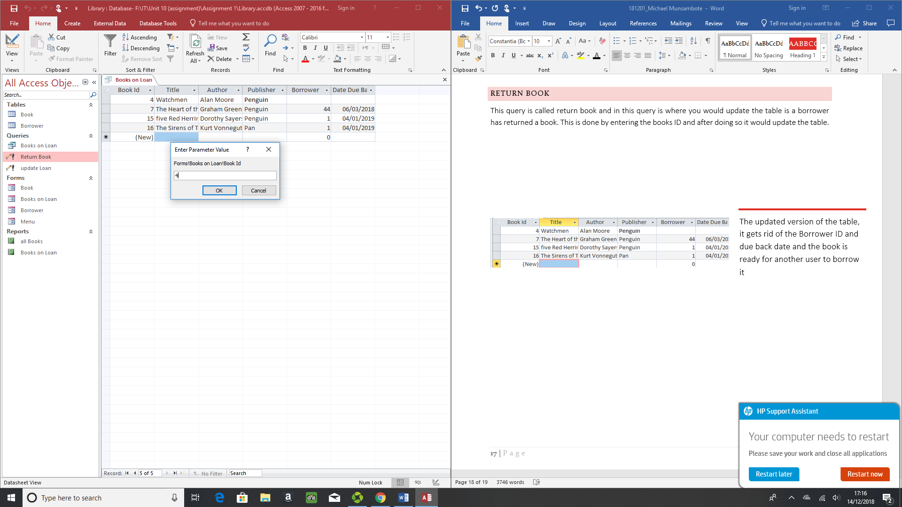
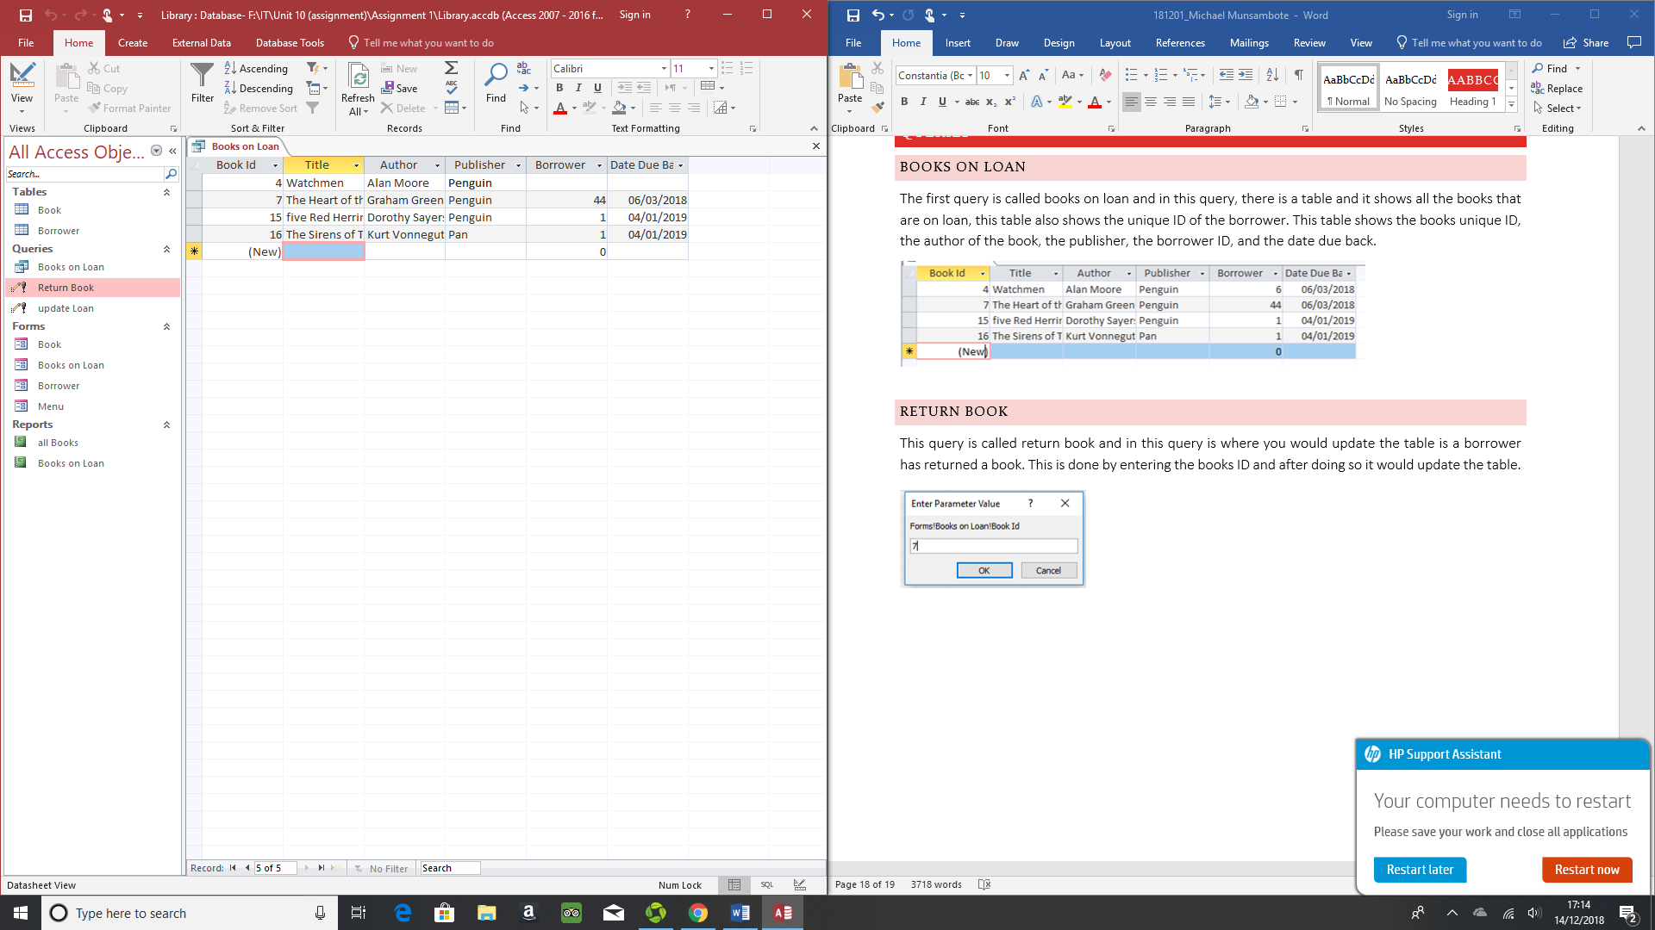

UPDATE LOAN
The final query is called update loan and in this query is where you would update the query if someone has borrowed a new book. It would update the books on loan table.
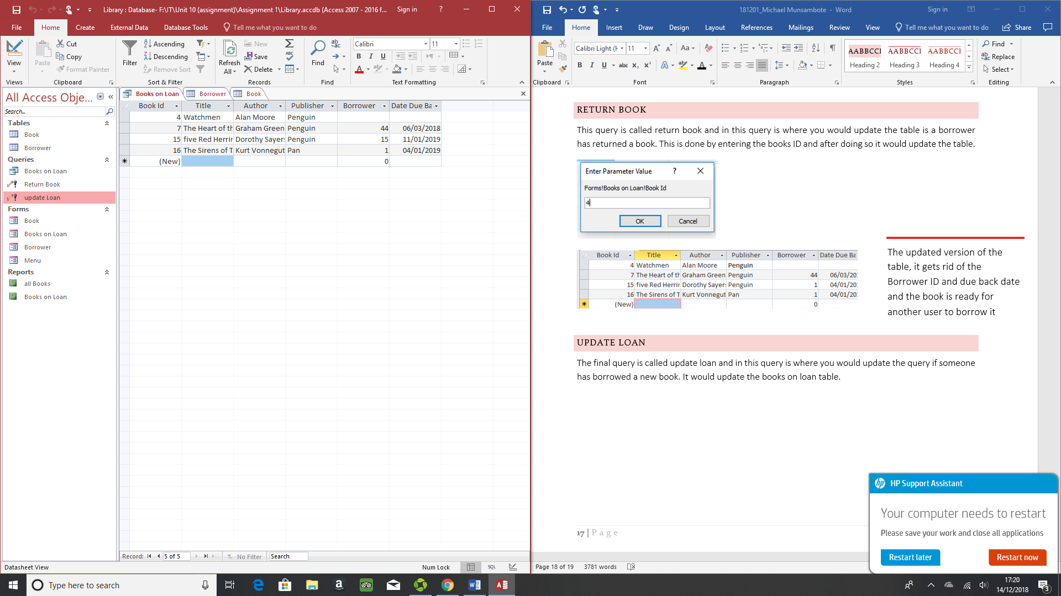
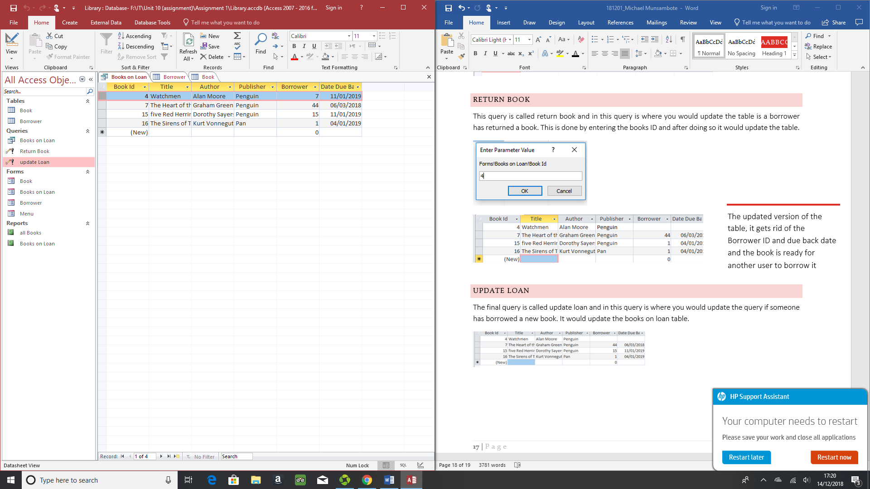

ADVANTAGE & DISADVANTAGE OF THE LIBARY DATABASE

ADVANTAGE
An advantage of this database that the headings are clear and readable. Another advantage is that you can clearly see which book the library has available. In the borrower section all the customs are clearly placed with their correct information. The tables automatically update themselves. There aren’t mistakes with the borrower details when it appears in the book table, (advantage of one to many relationship). In the reports you can see all the available books.

DISADVANTAGE
There aren’t any disadvantages to this database as all the features work, and there aren’t any incomplete section.

